St Andrew’s and St Bride’s High School
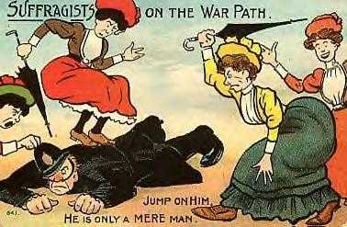

SUFFRAGETTES

S2 History

Lesson One

ATTITUDES TOWARDS WOMEN IN THE 19TH CENTURY

You are going to use the following selection of historical sources to find out what society believed about the position of women in the 19th century.

Read the sources carefully and answer the questions that follow.

SOURCE 1 A LETTER FROM QUEEN VICTORIA, 1870

The queen is most anxious to enlist everyone who can speak or write to join in checking this mad, wicked folly of “Women’s Rights” with all its attendant horrors, on which the poor feeble sex is bent on forgetting every sense of womanly feeling and propriety, (propriety = good manners)

Lady Amberley (in favour of more rights) ought to get a good whipping. Women would become the most hateful, heartless and disgusting of human beings were she allowed to unsex herself; and where would the protection which man was intended to give the weaker sex.”

- Is Source 1 a primary or secondary source?

- What surprises you about ‘Queen Victoria’s’ attitude towards women?

- Describe her attitude with at least 3 references to what she says. (quote to support)

SOURCE 2 – LORD TENNYSON, POET, “THE PRINCESS” (1847)

“Man for the field and woman for the hearth
Man for the sword and the needle she
Man with the head and woman with the heart
Man to command and woman to obey
All else confusion”

- Which sex does Tennyson see as superior? (Refer to the poem at least twice to explain your answer)

SOURCE 3 – THOMAS HUXLEY, A FAMOUS BIOLOGIST, WROTE:

“In every character, whether mental or physical the average woman is inferior to the average man, in the sense of having less in quantity and lower in quality. Even in physical beauty man is superior.”

- Why should historians be interested in the views of Huxley?

SOURCE 4 – SEPARATE SPHERES DESCRIBED BY A MODERN HISTORIAN

“A man’s sphere was outside the home, working and earning enough to look after his family. A woman’s sphere was inside the home, creating a welcoming home for her family. Women were not expected to work outside the house.”

- Is Source 4 a primary or secondary source?

The views in Sources 1-4 were seen to be the majority male view in Victorian Britain. There were however a minority who viewed women in a different way. One of these was a man called John Stuart Mill who used his position as a writer to draw attention to the unfair treatment of women. He tried to persuade Parliament to give women the vote in 1866. Emmeline Pankhurst (a famous Suffragette) describes why women need the vote.

SOURCE 5 – EMMELINE PANKHURST 1903
“Women need the vote to achieve equal rights. We want better living and working conditions. Having the vote brings improvements. But because women don’t have the vote, Parliament ignores us. Just look at the things we women have to put up with.”

7. Explain the reasons why Emmeline Pankhurst think women need the vote?

Extension Work

- In a paragraph describe the majority male view in Victorian times. Try to refer to each of Sources 1-4 in your answer.

