Has Trump kept his campaign promises?

The wall
Let's start with the wall - not the president's only promise, but certainly one of his oldest, most high-profile ones. Candidate Trump constantly spoke of the great wall that he plans to build along the US-Mexico border at his campaign rallies, and the crowd roared in agreement when he said Mexico would pay for the project. One of his first orders declared that the US would build a "physical wall" or "impassable physical barrier" along the border with Mexico, which already has some 650 miles of fencing.
But Mr Trump needs Congressional approval for funding before construction can begin and that is yet to happen. He insists the costs will be recouped from Mexico, despite its leaders saying otherwise.
Contrast that certainty with this tweet, which the president wrote over the weekend. "Eventually, but at a later date so we can get started early, Mexico will be paying, in some form, for the badly needed border wall," he tweeted.
It's a case of Trump promises meeting political realities, in 140 characters or less. Campaign rhetoric is easy; turning talk into action in Washington is much more complicated.
The administration has pledged to reshuffle some moneys to begin wall construction, but it is increasingly clear that Congress will need to find billions of dollars to make the wall a reality. That sets up a showdown between the president and legislators, with many Republicans - particularly those representing areas along the US-Mexico border - not keen on opening up the federal purse for Mr Trump's pet project.

Supreme Court
Mr Trump promised to choose a Supreme Court justice to fill the empty seat on the bench from a list he released during the presidential campaign - and, by tapping Neil Gorsuch, he did.
"I've always heard that the most important thing that a president of the United States does is appoint people - hopefully great people like this appointment - to the United States Supreme Court," Mr Trump said at Mr Gorsuch's White House swearing-in ceremony. "And I can say this is a great honour. And I got it done in the first 100 days. That's even nice. You think that's easy?"
That kind of depends how one defines "easy". Mr Gorsuch's confirmation hearing was bruising, no doubt. Facing united Democratic opposition, Republican Senate leader Mitch McConnell broke with longstanding precedent to allow a simple majority vote for Supreme Court confirmations. Once that was done, however, it was simply a matter of the Republican majority in the Senate imposing its will.
- Gorsuch sworn in as justice
While Mr Trump may have only had to put a name on a piece of paper and rely on Senate Republicans to do the heavy lifting, he did tick a major item of his presidential to-do list. He satisfied a Republican base that stuck with him through a tumultuous campaign on the understanding that they'd get just such a reliable conservative on the court. They may continue to stand by this president in the hope there will be more nominees like Mr Gorsuch to come.
Healthcare
It's way too early for political epitaphs, but if the Trump presidency collapses under the weight of disorganisation and broken promises, this February quote from the president - made as it became increasingly clear his own party couldn't even agree on healthcare reform - will make a fitting inscription for a tombstone.
At one point during the presidential campaign, Mr Trump promised that the Democratic healthcare reform legislation - Obamacare, as it has become known - would be repealed on his first day in office.
Then, after the first Republican legislative effort crashed and burned in late March - 64 days into his presidency - Mr Trump backtracked on his timeline.
"I never said repeal it and replace it within 64 days," he said. "I have a long time. But I want to have a great healthcare bill and plan, and we will. It will happen. And it won't be in the very distant future." Since then there's been speculation that a new deal could be in the works - but such rumours have evaporated upon closer scrutiny.
There's no telling what the future may bring, but the reality at this point is that healthcare reform was Mr Trump's first major legislative push - the de facto focus of his first 100 days in office - and it has done nothing but expose the Republican Party as fractured body incapable of advancing a coherent agenda.

Immigration
Mr Trump may have a bit of a mixed record when it comes to fulfilling his promises on immigration, but it's not for a lack of trying. His administration has taken two shots at curtailing the US refugee programme and preventing citizens of a handful of majority Muslim nations from entering the US, but those executive actions have been stymied by a handful of court judges (one, as Attorney General Jeff Sessions put it, residing on an "island in the Pacific").
Mr Trump has also stepped up immigration enforcement across the US, threatened "sanctuary cities" that don't co-operate fully with federal immigration officials, ordered a review of immigration programmes, including H-1B visas given to high-skilled immigrants, and announced a hiring spree on border patrol agents and immigration court judges.
Immigration arrests were up 32.6% in the first month and a half of the Trump presidency, according to the Washington Post, with a larger share coming from those without a prior criminal record. Meanwhile, border apprehensions have dropped. Trump he has signed two executive memos that instruct immigration officers to take a much tougher approach towards enforcing existing measures. There are signs that this change in immigration enforcement - and President Trump's tough rhetoric - may have led to a drop in the number of people trying to cross illegally into the US. In March, the number of people apprehended while crossing from Mexico fell to its lowest level for 17 years, according to Homeland Security Secretary John Kelly.
Mr Kelly said the drop was "no accident" and the Customs and Border Protection agency said President Trump's executive orders had led to a "marked change in trends".
The new president's talk of a crackdown on illegal immigrants makes it sound as if they had an easy ride under President Obama, but there is plenty of evidence to suggest the opposite is true.

Foreign policy
During the campaign, Mr Trump's foreign policy vision was a collection of sometimes contradictory, often controversial proposals- getting tough on the so-called Islamic State, Iran and China, reaffirming an alliance with Israel and mending relations with Russia. He entertained the notion of lifting restrictions on the use of torture on detainees and giving the US military more authority to act, including by targeting the families of suspected militants. He promised to put American priorities first and downplayed support for US allies and international alliances that he deemed too burdensome.
He pulled the US out of the Trans-Pacific Partnership as promised and has begun a review process for the North American Free Trade Agreement.
Torture remains off the table, thanks to the influence of Defence Secretary James Mattis. Mr Trump has occasionally told foreign leaders - Germany's Angela Merkel and Italy's Paolo Gentiloni, for instance - of his expectations that they increase their military spending. On the other hand, he has recently acknowledged the value of Nato membership.
When it comes to China, however, he's taken a softer line. He's backed away from his promise to label the nation a "currency manipulator" or impose steep import tariffs, instead seeking the nation's help in dealing with North Korea.
Then there's Mr Trump's missile strike on Syrian forces following that government's use of chemical weapons on its own people. It's the kind of move that candidate Trump may have dismissed as ineffective - and, in fact, reality TV star Trump had condemned in no uncertain terms in 2013, when Barack Obama proposed his own Syrian intervention.
Infrastructure, taxes, childcare…
Trump announced a "100 Day Plan to Make America Great Again" outlining legislation he would "work with Congress to introduce" and "fight for" in his first 100 days. They included the Middle Class Tax Relief and Simplification Act, the End the Offshoring Act, the Affordable Childcare and Eldercare Act, the Repeal and Replace Obamacare Act, and the American Energy and Infrastructure Act.
Aside from Obamacare repeal effort, which is currently a smoking crater somewhere on the floor of the House of Representatives, the rest of these pieces of legislation remain in the realm of unicorns and fairies. Mr Trump has said details of a tax plan are coming as soon as this week, but - as we saw with healthcare - a detailed plan creates a juicy target for opponents of all political stripes. The president signed a raft of executive actions - rolling back Obama-era regulations, authorising the construction of the Keystone XL pipeline and instituting a federal hiring freeze (which has since been lifted) - but in the vast scheme of things those are low-hanging fruit for a new president.
Mr Trump has signed more laws at this point than any president since Truman - but that list includes Veterans' medical clinics, appointments to museum boards and a memorial to the Gulf War. The remaining laws rolled back Obama regulations, most had yet to go into effect.
Legislation that can last beyond any one president is a heavier lift, and Mr Trump has yet to show he has any real muscle. Promise kept? Consult your nearest unicorn.

A change of tone
Mr Trump is far from a traditional president, so perhaps it's unfair to evaluate the first few months of his presidency in traditional ways, such as by tallying up his policy accomplishments and failures. His voters largely didn't back his candidacy based on specific promises - on the wall, on healthcare, on taxes - but because of his attitude and his promise to shake up the political system. If the performance metric is how much the Trump presidency has disrupted politics as usual, Mr Trump has posted a clear victory.
He continues to dominate the national conversation with his controversial tweets and off-the cuff statements, and his actions have defied traditional political norms and standards, whether it's his apparent steadfast refusal to fill lower-level political appointments or observe precedents on open-government practices. He's lectured foreign leaders, browbeat major companies and taken a poleaxe to disfavoured media (while still giving them choice interviews when it serves his purposes, of course).
Mr Trump campaigned on draining the swamp, and he's taken some executive actions to limit administration officials from becoming lobbyists after they leave government service. On the other hand, his promises to avoid conflicts of interest over his wide-ranging business empire have proven vague and unenforceable and he's stocked his administration with the kind of financial insiders and Wall Street bigwigs he regularly railed against on the campaign trail.
So far, however, his dedicated supporters - the ones who powered him to a narrow electoral victory if not a popular vote plurality - seem pleased as punch. According to a recent poll, 96% of Mr Trump's voters in November stand by their support of the man. They've apparently seen enough action to convince them that the president is doing what he said he'd do, even if it hasn't yet translated into legislative accomplishments.
If the economy is humming and unemployment stays low, they'll probably remain in his corner for the long haul. For them, the apparent chaos in the nation's capital is a feature, not a bug.

What has been done on healthcare?

Healthcare was always going to be an early test for President Trump after he made it a centrepiece of his election campaign.
President Obama's Affordable Care Act helped more than 20 million previously uninsured Americans to finally get health cover - but Mr Trump said he would "immediately repeal and replace" it.
Republicans eventually unveiled their long-awaited draft healthcare bill at the beginning of March, with House Speaker Paul Ryan describing it as "monumental, exciting conservative reform".
President Trump backed the bill but it received a damning assessment from the Congressional Budget Office (CBO), a nonpartisan federal agency, which said it would result in 24 million more uninsured Americans by 2026.
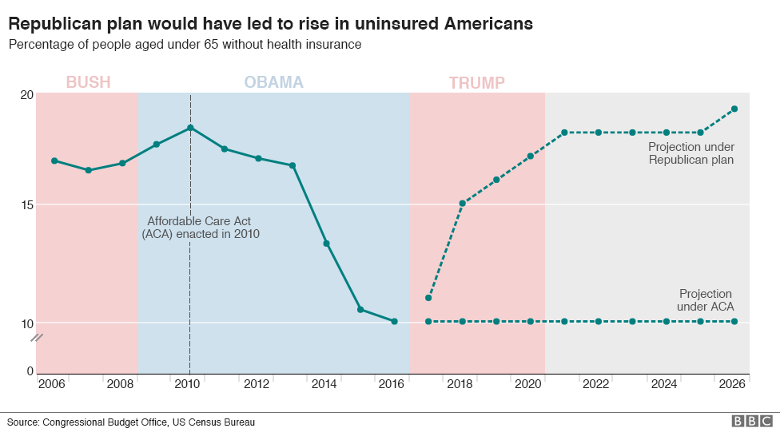
The Trump administration said it "strenuously disagreed" with the CBO analysis, but the bill was abandoned on 24 March after it failed to win enough support from Republicans in Congress. It was an embarrassing episode for President Trump and the Republican Party, which controls the presidency and both chambers of the Congress for the first time in 11 years. Mr Trump did his best to shrug off the defeat, saying his administration would return to "piece together a great healthcare plan" once Obamacare had "exploded".
How disastrous for Trump is healthcare collapse?
While Obamacare has had its problems since it was introduced in 2010, it shows few signs of collapsing in the near future and the CBO analysis said its marketplaces were "stable in most areas". That could change if President Trump and his Republican colleagues move to cut funding for the programme's subsidies, but that would be a risky strategy ahead of mid-term elections next year, especially as recent polls suggest support for Obamacare is actually growing.
Republicans have promised a new healthcare plan after the Easter break but it is unclear as yet what is in it, whether the party will unite behind it and whether it would earn enough votes to advance into law.

What executive actions has Trump taken?
One way President Trump is able to exercise political power is through unilateral executive orders and memoranda, which allow him to bypass the legislative process in Congress in certain policy areas.
While it may appear that he has used executive actions at an unprecedented rate, he signed about the same number as his predecessor, Barack Obama, did during his first weeks in office, though Mr Trump has since pulled ahead.
Several of President Trump's executive actions have been designed to deliver on some of his campaign promises, but they are limited in their power.
While executive orders can be used to change how federal agencies use their resources, they cannot assign those agencies new funds or introduce new laws - both of those powers are held by Congress.
For example, Mr Trump's first executive order was designed to limit the effect of the Affordable Care Act, but his campaign promise of repealing and replacing it can only be enacted by Congress because it requires new legislation.
One of the first ways a new president is able to exercise political power is through unilateral executive orders.
While legislative efforts take time, a swipe of the pen from the White House can often enact broad changes in government policy and practice. President Donald Trump has wasted little time in taking advantage of this privilege. Given his predecessor's reliance on executive orders to circumvent Congress in the later days of his presidency, he has a broad range of areas in which to flex his muscle.

Climate change policy reversal
Mr Trump signed the order at the Environmental Protection Agency (EPA) undoing a key part of the Obama administration's efforts to tackle global warming. The order reverses the Clean Power Plan, which had required states to regulate power plants, but had been on hold while being challenged in court. Before signing the order, a White House official told the press that Mr Trump does believe in human-caused climate change, but that the order was necessary to ensure American energy independence and jobs. Environmental groups warn that undoing those regulations will have serious consequences at home and abroad.

Travel ban

After an angry weekend in Florida in which he accused former-president Barack Obama of wiretapping his phones at Trump Tower, Mr Trump returned to the White House to sign a revised version of his controversial travel ban. The executive order titled "protecting the nation from foreign terrorist entry into the United States" was signed out of the view of the White House press corps on 6 March.
The updated ban:
- Temporarily halts entry to citizens for 90-days of six Muslim-majority countries (Iran, Libya, Syria, Somalia, Sudan and Yemen)
- Removes Iraq from the previous list, due to increased vetting of its own citizens
- Delays implementation until 16 March
- Allows current visa holders to travel to the US
- Does not affect permanent visa holders (Green Card holders)
- Suspends the refugee programme for 120 days
- Treats Syrians like any other refugee or immigrant
- Removes the religious clause favouring religious minorities - namely Christians
Immediate impact: Soon after the order was signed, it was once again blocked by a federal judge, this time in Hawaii.

