**NATIONAL 5 SKILLS BOOKLET**

**St Andrews and St Brides High School**

* **Options**: using sources of information to make and justify a decision, and explaining why you did not choose the alternative option. (**10 marks**)
* **Selective in use of facts** – using sources of information to identify evidence that supports and evidence that opposes a given statement (**8 marks**)
* **Conclusions**: using sources of information to make and justify conclusions. (**8 marks**)

**Contents**

Options example 1.……………………………………….page 3

**Options marking scheme and model answer**..…………page 5

Options example 2………………………………………..page 6

Options example 3..………………………………………page 9

Options example 4………………………………………..page 12

Options example 5………………………………………..page 15

Options example 6………………………………………..page 18

Options example 7………………………………………..page 21

Options example 8………………………………………..page 24

Selective example 1……………………………………....page 26

**Selective marking scheme and model answer**…………page 28

Selective example 2……………………………………....page 29

Selective example 3………………………………………page 31

Selective example 4………………………………………page 33

Selective example 5………………………………………page 35

Conclusions example 1…………………………………...page 37

**Conclusions marking scheme and model answer**……...page 39

Conclusions example 2…………………………………...page 40

Conclusions example 3…………………………………...page 42

Conclusions example 4…………………………………...page 44

Conclusions example 5…………………………………...page 46

Conclusions example 6…………………………………...page 48

Conclusions example 7…………………………………...page 50

**OPTIONS EXAMPLE 1**

**Nat 5 Specimen paper Options question:**

Study Sources 1, 2 and 3 below, then attempt the question which follows.

You are a government adviser. You have been asked to recommend whether the

Government should build the Melo Bonte Dam.

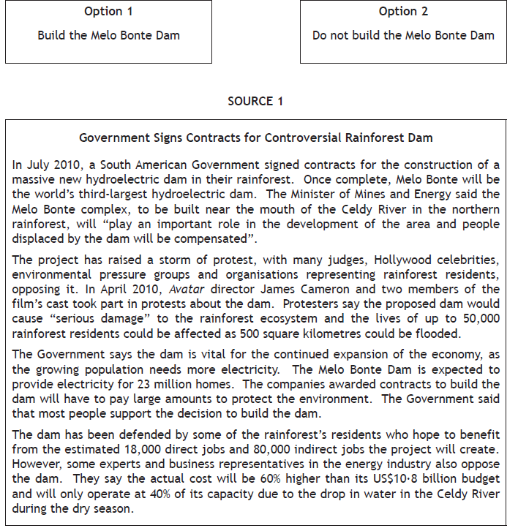

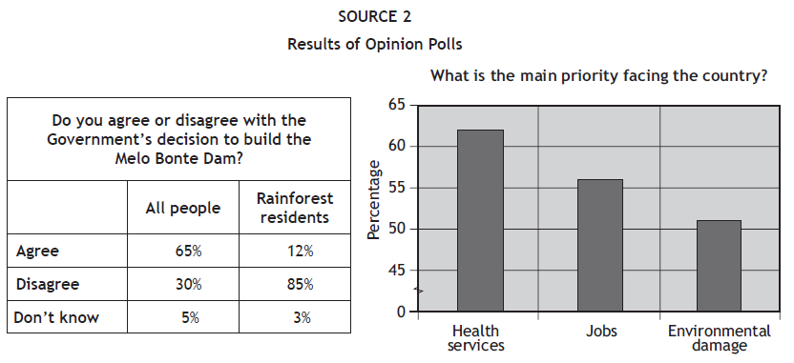

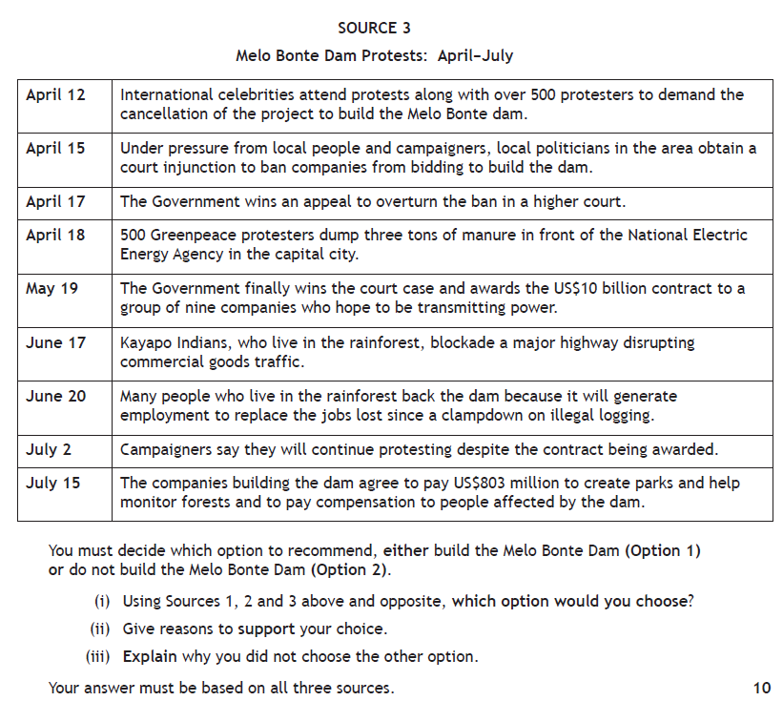

**OPTIONS MARKING SCHEME AND MODEL ANSWER**

*The candidate is required to use a limited range of sources, selecting evidence from them in order to make and justify a decision / recommendation.*

*You will be awarded up to three marks for a justification depending on relevance and development of the evidence.*

*You will be highly credited if you make justifications which show interaction between the sources.*

*For full marks, you must justify your decision / recommendation and explain why you have rejected the other option.*

*Answers which deal with only one decision will be awarded a maximum of 8 marks.*

*Across the whole answer you must use all 3 sources to achieve full marks.*

**Model Answer to National 5 Specimen Paper – 10/10 Using O T O A**

I have chosen Option 1 to build the Melo Bonte Dam.

My first reason for Option 1 is from Source 1 which clearly shows the Minister of Mines and Energy stating the dam will ‘play an important role in the development of the area’. This is linked to Source 1 which also states “the Government says the dam is vital for the continued expansion of the economy, as the population need electricity” and the dam would provide electricity for 23 million homes. This clearly shows that the dam would be beneficial.

My second reason for Option 1 is from Source 1 which points out that the Government say most people support the decision to build the dam. This is confirmed by Source 2, which shows 65% of all people polled agreed with the Government’s decision to build the dam. Just 30% of all people disagreed. This clearly shows the need to build the dam.

My third reason for Option 1 is from Source 3 which also points out that many people who live in the rainforest back the dam because it will generate employment. This is linked with Source 1 which also confirms that some of the rainforest’s residents hope to benefit from the estimated 18,000 direct jobs and 80,000 indirect jobs the dam will create. This is important as Source 2 shows over 55% of people feel jobs are the main priority facing the country. This clearly shows the need for the dam.

The reason I did not choose Option 2 – not to build the Melo Bonte Dam, as although Source 1 shows that protesters say the dam could cause ‘serious damage’ to the rainforest ecosystem, Source 2 shows that according to an opinion poll, people felt the environment was the least important priority facing the country. More thought jobs were more important, which the dam would create.

Another reason that I did not choose Option 2, as although Source 1 shows protesters are concerned that up to 50,000 rainforest residents could be negatively affected, Source 1 points out that the Government Minister of Mines and Energy has promised that those displaced by the dam would be compensated. Source 3 confirms this, showing that the companies building the dam agreed in July to pay $803 million to create parks and help monitor forests and to pay compensation to people affected by the dam, so the negative affects will be limited.

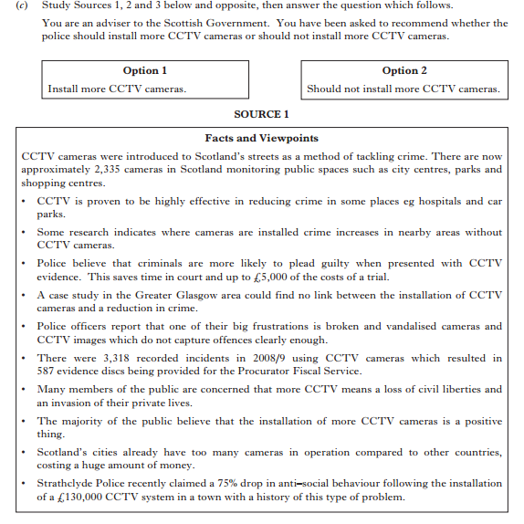**OPTIONS EXAMPLE 2**

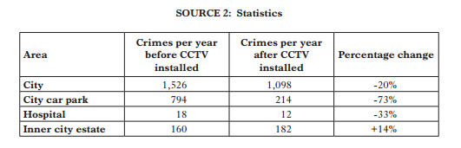

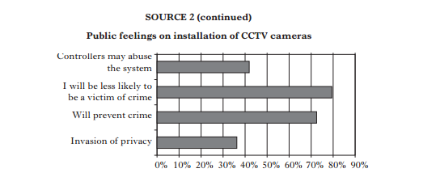

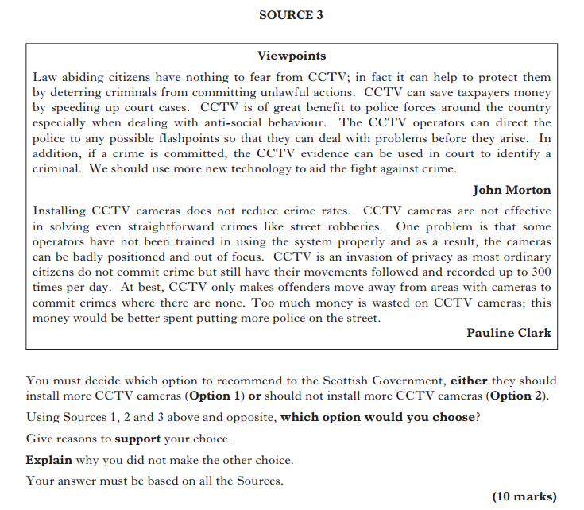

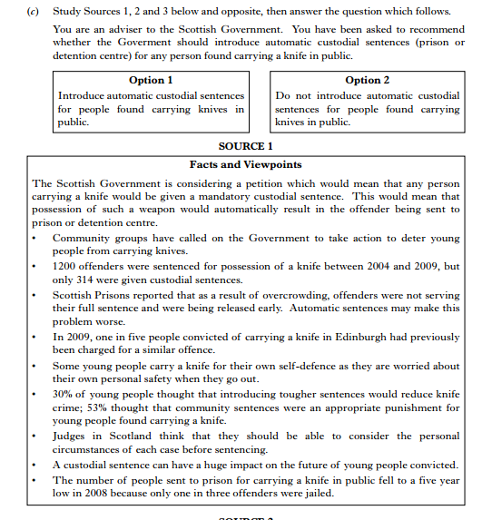**OPTIONS EXAMPLE 3**

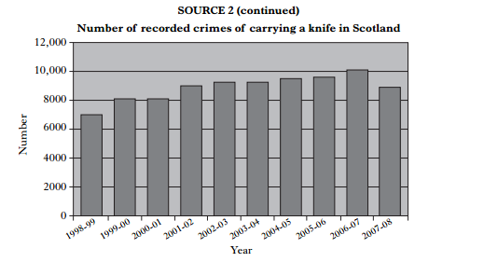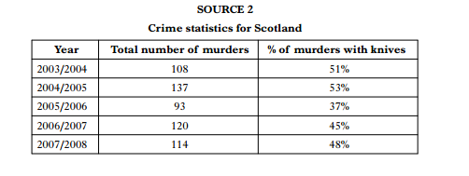

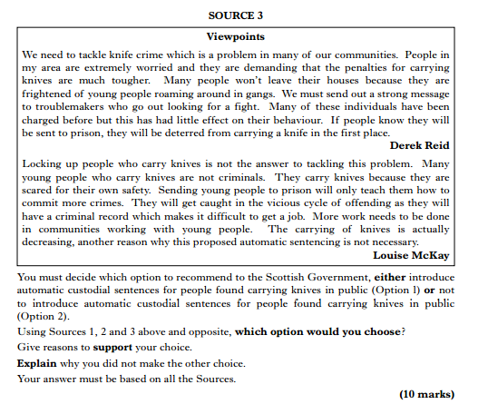

**OPTIONS EXAMPLE 4**

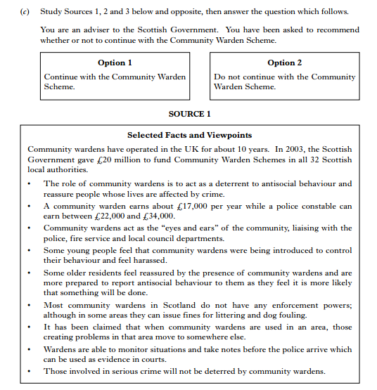

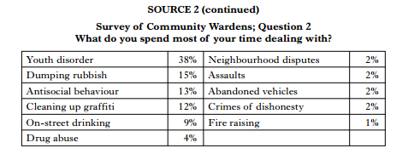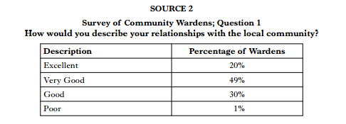

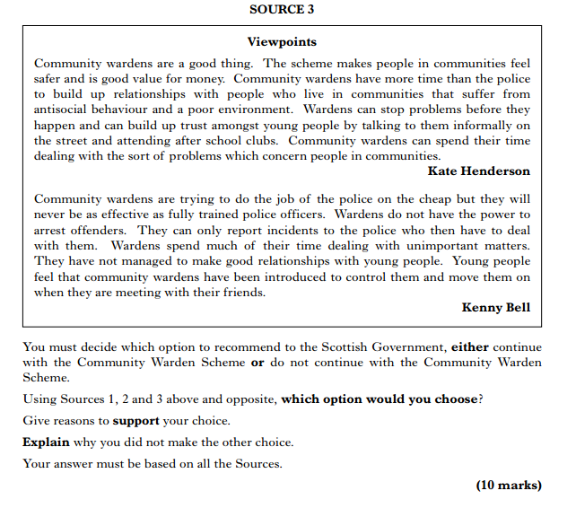

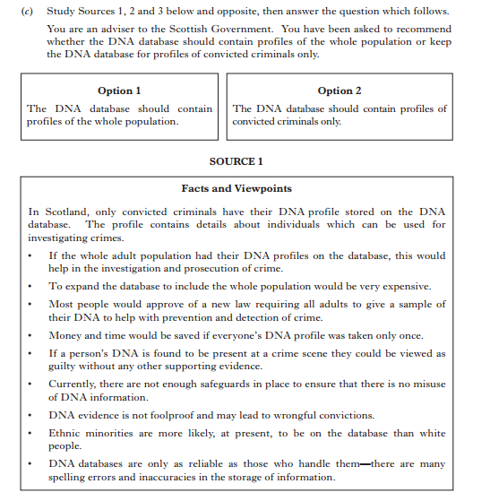**OPTIONS EXAMPLE 5**

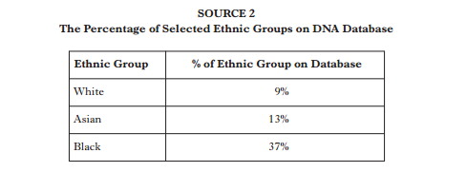

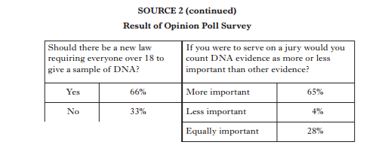

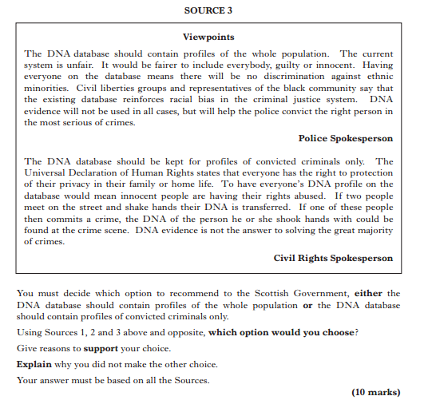

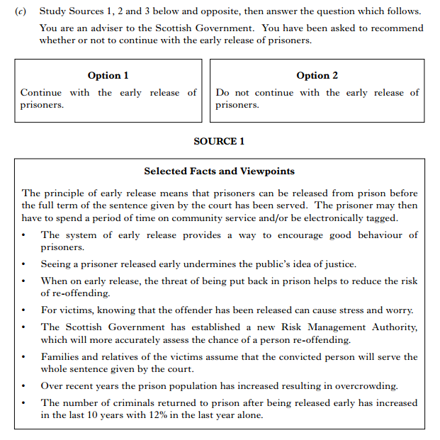**OPTIONS EXAMPLE 6**

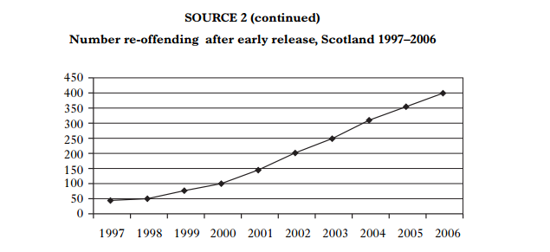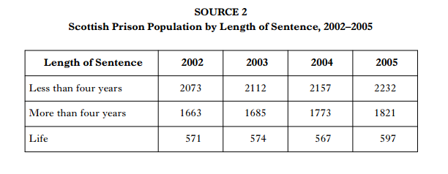

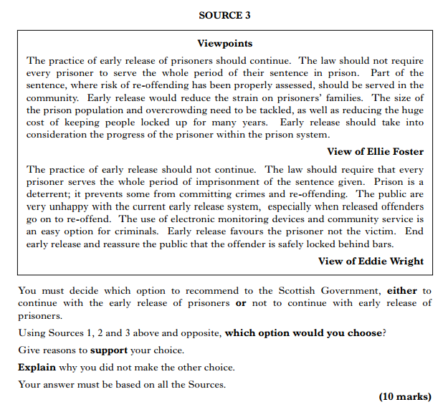

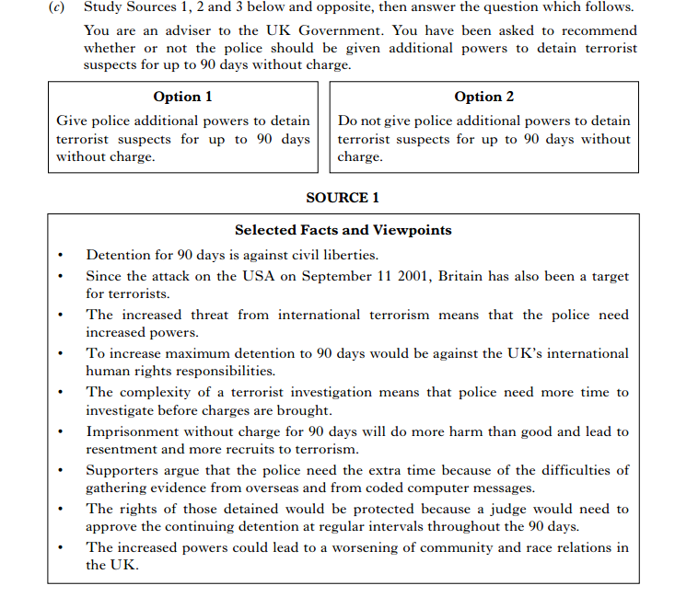

**OPTIONS EXAMPLE 7**

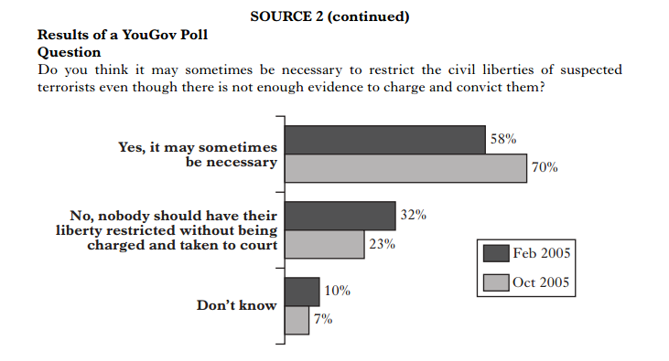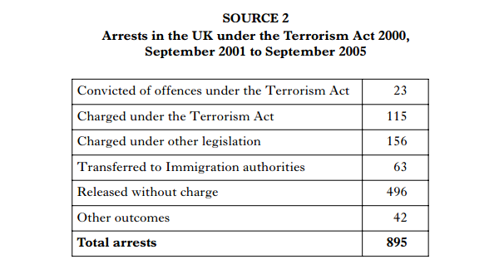

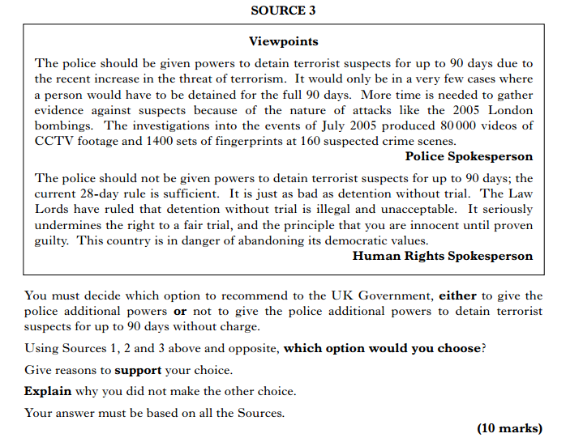

**OPTIONS EXAMPLE 8**

(from 2013 Int 2)

Study Sources 1, 2 and 3 below, then attempt the question which follows.

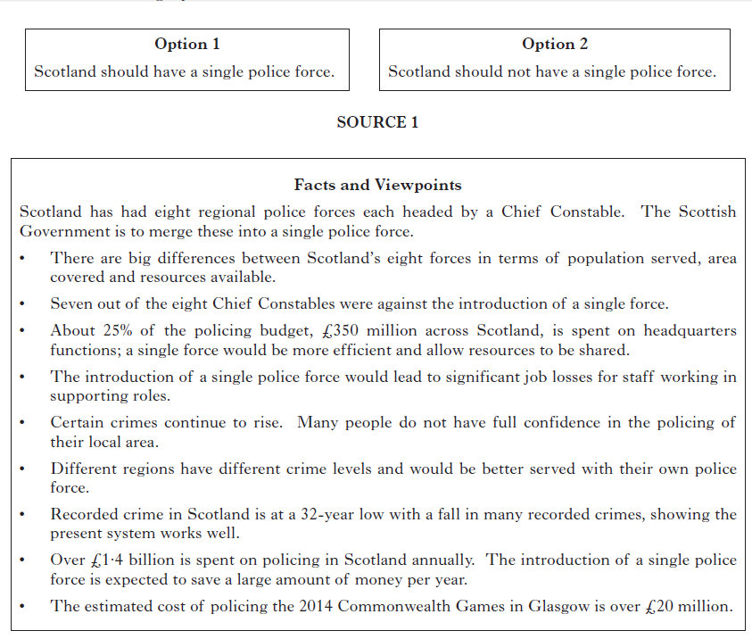You are an adviser to the Scottish Government. You have been asked to consider whether there should be a single police force in Scotland.

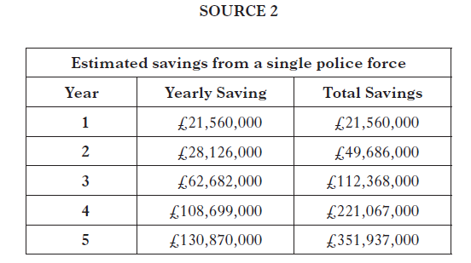

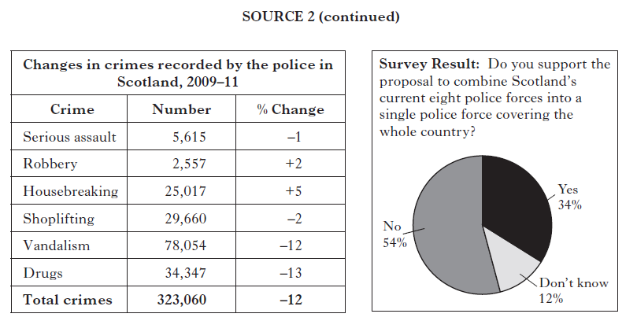

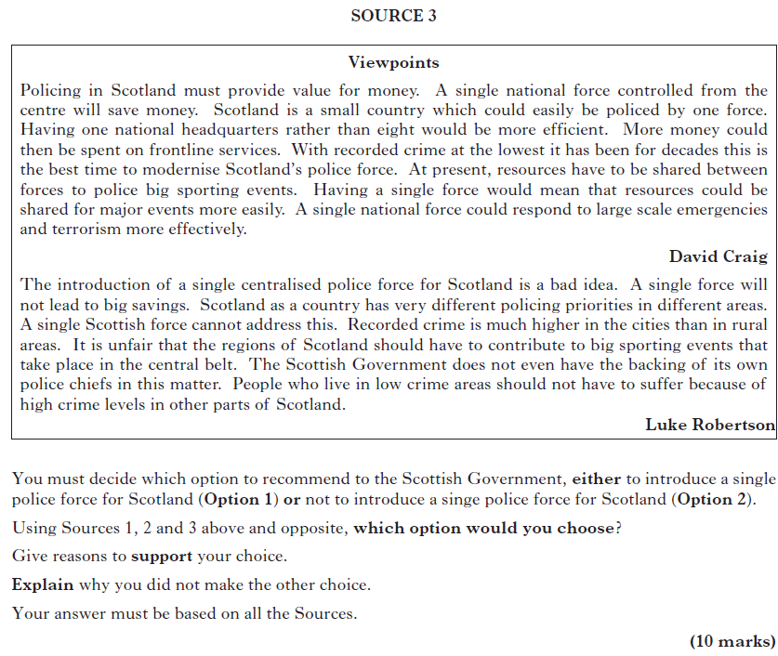

**END OF OPTIONS EXAMPLES**

**SELECTIVE IN THE USE OF FACTS**

**MARKING SCHEME AND MODEL ANSWER**

*The candidate is required to evaluate a limited range of sources, detecting and explaining instances of exaggeration and/or selective use of facts, giving developed arguments.*

*In order to achieve full marks candidates must show evidence that has been selected as it supports the view and show evidence that has not been selected as it does not support the view.*

*An answer which deals with only one side of the explanation should be awarded a maximum of 6 marks.*

*For full marks, candidates must explain why the statement is selective in the use of facts; otherwise only a maximum of 6 marks can be awarded.*

*Candidates can be awarded up to 3 marks for a developed explanation depending upon the quality of argument and accurate use of information.*

|  |
| --- |
| *Remember:*  *Selective-Not Supported-Fib*  *Not Selective-Supported-Truth* |

**Selective in the use of facts Model answer : Using S W A N**

***Mr Smith cannot be supported when he says “quote statement“, because Source X shows that “quote source”. This shows that…. (link statement and source).***

***This clearly shows that Mr Smith has been selective in his use of facts as it is clear that she has chosen to use the information from the sources and……state the reason why!***

***I can support Mr Smith when he says “quote statement“. This is clearly shown in Source X which shows that “quote source”. This is supported by evidence in Source X which shows that (link statement and source).***

***This clearly shows that he has not been supportive in the use of facts because the sources show that…..state reason why!***

**SELECTIVE EXAMPLE 1**

(From 2012 Int 2 and Nat 5 Prelim)

Study Sources 1, 2 and 3 below, then attempt the question which follows.

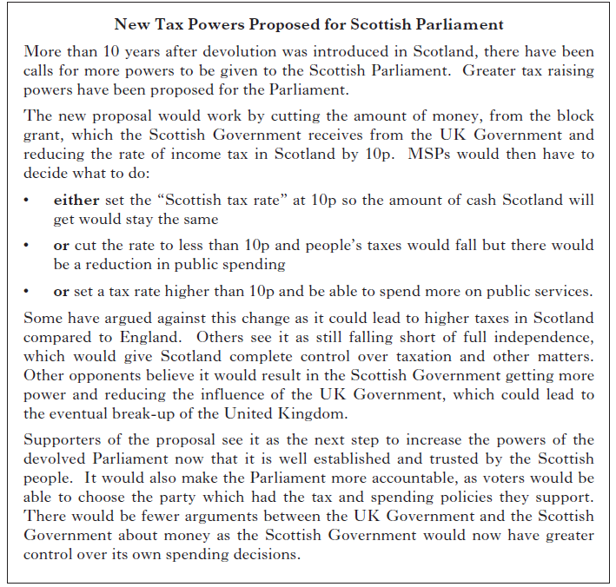

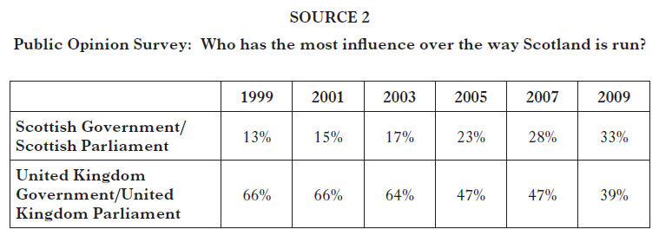

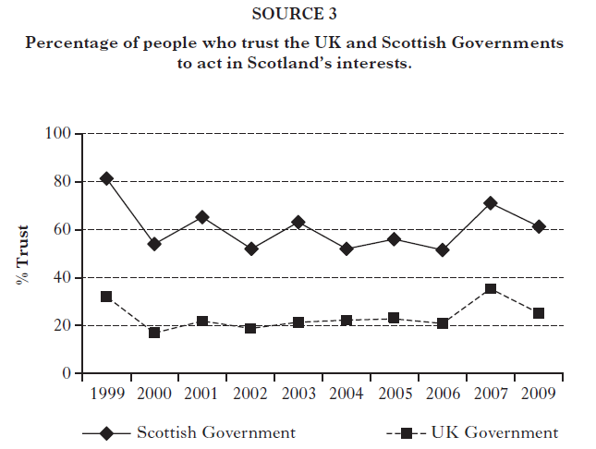

Using Sources 1, 2 and 3 above, explain why the view of Gillian Duffy is **selective in the use of facts.**

**New tax raising powers for the Scottish Parliament would be good for Scotland**.

**View of Gillian Duffy.**

In your answer you must:

* Give evidence from the sources that supports Gillian Duffy’s view

And

* Give evidence from the sources that opposes Gillian Duffy’s view
* Your answer must be based on all three sources. **8**

**Model answer 8/8 to above question**

Gillian Duffy can not be supported when she says “New tax raising powers for the Scottish Parliament would be good for Scotland”. Source 1 clearly shows that it could lead to higher taxes in Scotland compared to England*. This can be further supported by evidence from source 1 which shows that* it could reduce the influence of the UK Government and lead to the eventual break-up of the UK and evidence from source 1 stating that more people believe the UK Government/Parliament has most influence over the way Scotland is run.

She can also not be supported when Source 1 states that new tax raising powers would give the UK government an excuse to reduce the funding to the Scottish Government and Parliament and this could lead to less spending on health and education and this could make the Scottish Government less popular and reduce trust. This can also be supported by Source 3 which shows that trust in the Scottish Parliament has declined from 70% in 2007 to 60% in 2009.

This clearly shows that Gillian Duffy has been slightly selective in her use of facts as it is clear that she has chosen to use the information from the sources and show that there are a number of negative views on whether new tax raising powers would be good for Scotland.

I can support Gillian Duffy when she says “New tax raising powers for the Scottish Parliament would be good for Scotland”. It is clearly shown in Source 1 which shows that the Scottish Parliament could choose to have lower taxes or spend more on public services. This is supported by evidence in Source 1 which shows that the Parliament is more accountable as voters could choose the party which had the tax and spending policies they support. This is also evidenced in Source 2 which shows the percentages of people who think the Scottish government has more power has risen since 1999 while the percentage of people who think the UK government has more power has fallen since 1999.

I can also support Gillian Duffy using evidence from Source 1 which shows that Scotland has had devolution for 10 years which links to evidence from Source 1 which states that some believe new tax-raising powers are the next step to increase the powers of the devolved Parliament now that it is well established and trusted by the Scottish people. This is supported in Source 3 which shows that 61% think the Scottish Parliament can be trusted to act in Scotland’s interests compared with only 24% who think the UK Parliament can be trusted to act in Scotland’s interests in 2009.

This clearly shows that Gillian Duffy has not been selective in her use of facts because the sources show that many people have views which think that new tax raising powers are a good thing.

**SELECTIVE EXAMPLE 2**

(From Specimen paper)

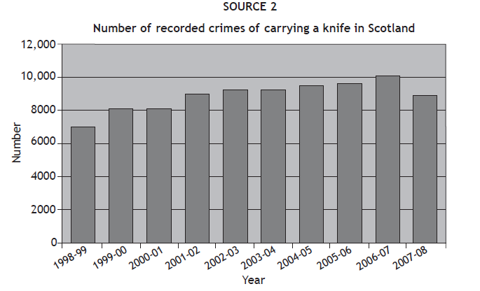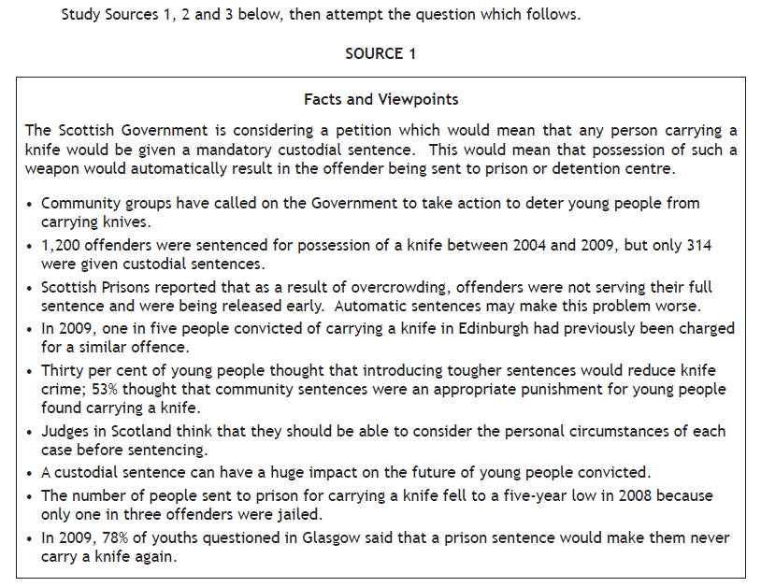

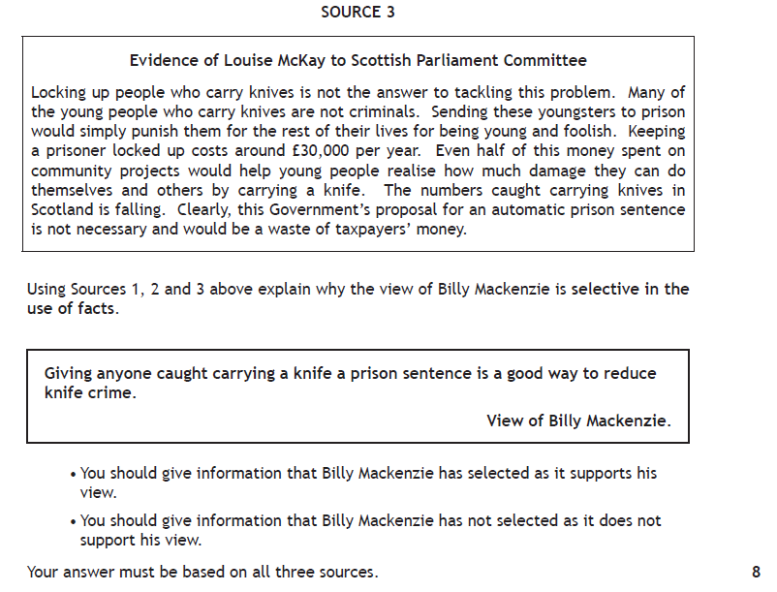

In your answer you must:

* Give evidence from the sources that supports Billy MacKenzie’s view

And

* Give evidence from the sources that opposes Billy MacKenzie’s view

Your answer must be based on all three sources. **8**

**SELECTIVE EXAMPLE 3**

(from Specimen paper)

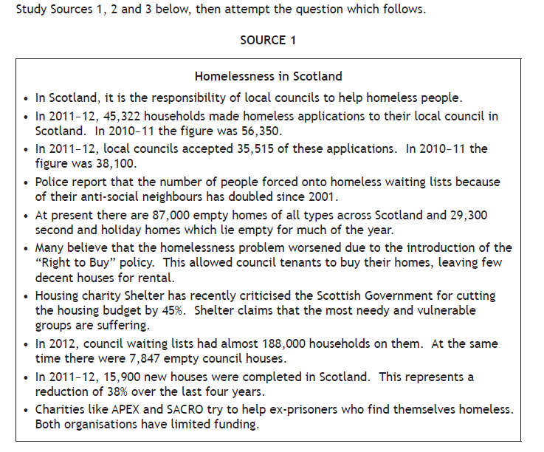

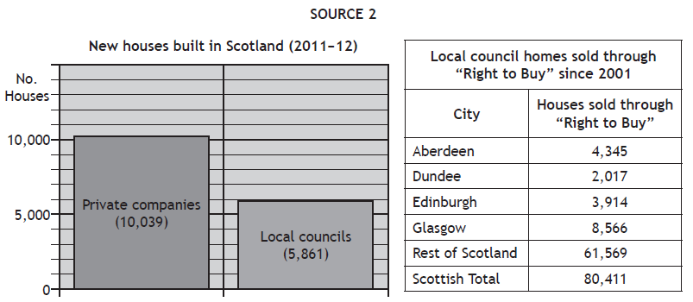

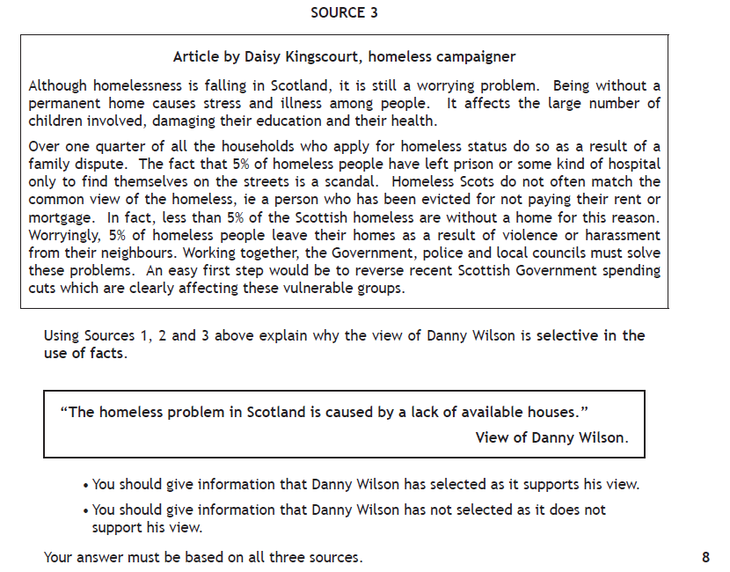

 In your answer you must:

* Give evidence from the sources that supports Danny Wilson’s view

And

* Give evidence from the sources that opposes Danny Wilson’s view

Your answer must be based on all three sources. **8**

**SELECTIVE EXAMPLE 4**

(From 2013 Int 2)

Study sources 1, 2 and 3 below, then attempt the question which follows.

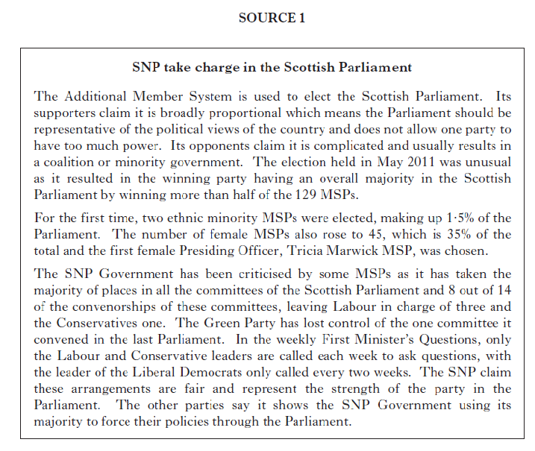

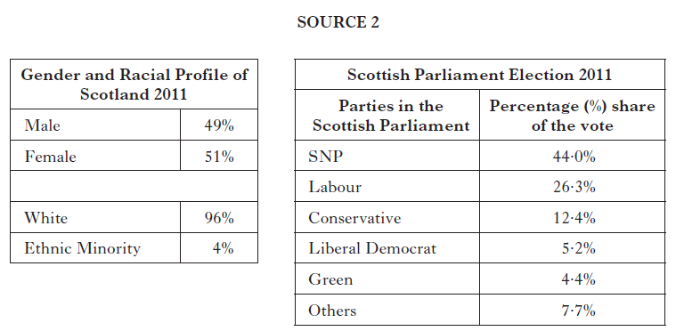

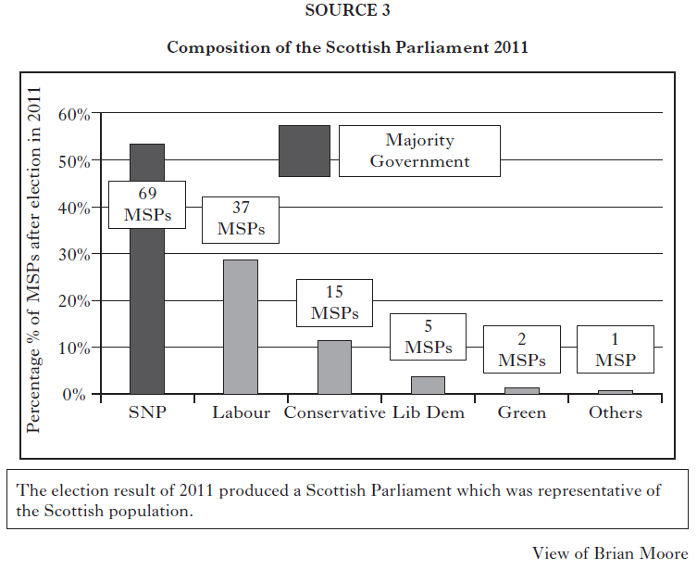

Explain why the view of Brian Moore is selective.

In your answer you must:

* Give evidence from the sources that supports Brian Moore’s view

And

* Give evidence from the sources that opposes Brian Moore’ view

Your answer must be based on all three sources. **8**

**SELECTIVE EXAMPLE 5**

(From 2012 Int 2)

Study sources 1, 2 and 3 below, then attempt the question which follows.

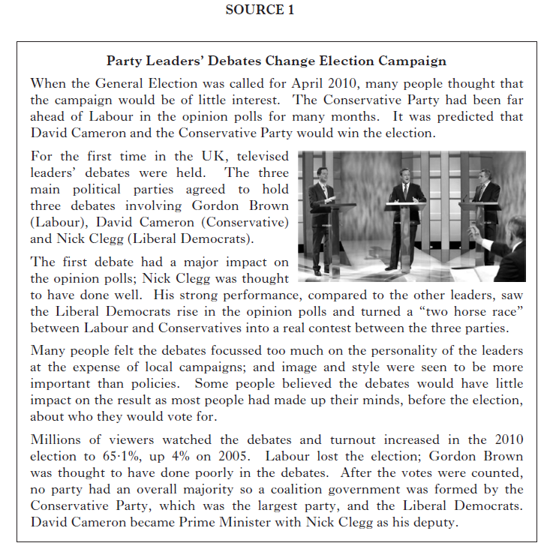

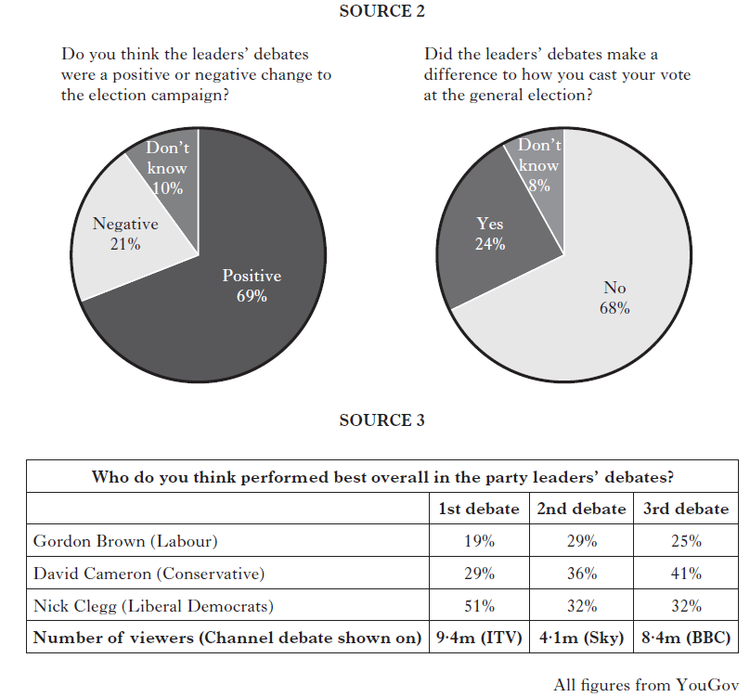

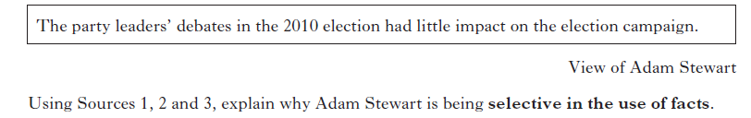

In your answer you must:

* Give evidence from the sources that supports Adam Stewart’s view

And

* Give evidence from the sources that opposes Adam Stewart’s view

Your answer must be based on all three sources. **8**

**END OF SELECTIVE EXAMPLES**

**CONCLUSIONS MARKING SCHEME AND MODEL ANSWER**

*The candidate is required to use the sources provided to draw valid conclusions, with supporting evidence. You should draw conclusions using the headings / bullet points in the question.*

*An answer which merely repeats the source material without making judgements or conclusions will be awarded zero marks.*

*For full marks three developed conclusions must be given. You should link information within and between sources in support of your conclusions.*

*A conclusion - is a statement - supported with evidence*

*- Consider what the question is asking.*

*- Look at the sources, make links between sources.*

*- Make a conclusion based on the evidence. It must not be the same as your evidence. Your conclusions are a statement, THEN give your statistical/source evidence.*

* *Candidates should draw 3 conclusions using the headings/bullet points in the question.*
* *Candidates should be highly credited if they draw conclusions which show interaction between the sources. Answers which merely repeat the source material without making judgements or drawing conclusions should be awarded zero marks.*
* *Be supported by valid evidence drawn from two sources or different parts of the same source*
* *Not be the same as your evidence. Your conclusion is a statement, THEN give your statistical/source evidence*
* *Make sure your conclusion evaluates, eg is more than, significant change, equal to, decreases dramatically........ Candidate must make an original and insightful conclusion of their own which is supported by more than one piece of valid evidence drawn from two sources or from different parts of the same source.*
* *The conclusion will make a judgement and use evaluative terminology.*
* *By the end of your question you should have used all the sources and have three, detailed, linked conclusions*

*Proforma Conclusion Answer Conclusion Original All Linking Sources Three COALST*

**Ist Conclusion point from question**

My first conclusion is that ______________________________.

I can support this conclusion using sources _ and _. Source __ states that_____________. Source __ also shows_____________________________. This can be further supported by Source ____ which provides further evidence ________________________________________________________________.

My second conclusion is that ______________________________.

I can support this conclusion using sources _ and _. Source __ states that_____________. Source __ also shows_____________________________. This can be further supported by Source ____ which provides further evidence ________________________________________________________________.

My third conclusion is that ______________________________.

I can support this conclusion using sources _ and _. Source __ states that_____________. Source __ also shows_____________________________. This can be further supported by Source ____ which provides further evidence ________________________________________________________________.

**CONCLUSIONS EXAMPLE 1**

(from Nat 5 Prelim)

Study sources 1, 2, and 3 below, then attempt the question which follows.

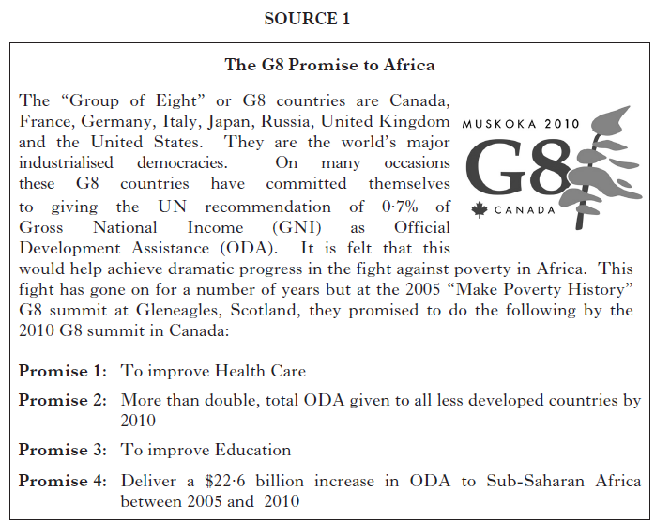

In terms of total ODA to all less developed countries, the G8 countries have all increased their contribution, with Canada almost doubling its ODA contribution. Recent health and education figures have been encouraging. Between 1996 and 2009 the % of HIV sufferers in Rwanda has declined from 7.0% to 2.8%.

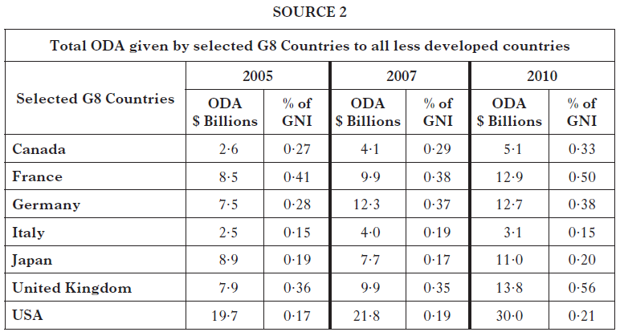

**SOURCE 3**

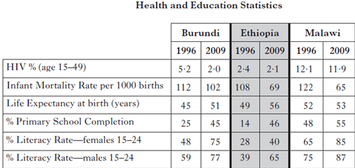

Using sources 1, 2 and 3 above, what **conclusions** can be drawn about the G8 and aid to African countries?

You should reach a conclusion about each of the following:

* The success of the G8 in meeting Promise 1
* The success of the G8 in meeting Promise 2
* The G8 country most committed to meet the UN aid recommendation

Your conclusions must be supported by evidence from the sources. You should link information within and between sources in support of your conclusions.

**Model answer 8/8 to above question**

* **The success of the G8 in meeting Promise 1**

My first conclusion is that G8 countries have been very successful in meeting Promise 1.

I can support this conclusion using sources 1 and 3. Source 1 states that Promise 1 is to improve health. Source 1 also shows that the % of people in Rwanda with HIV decreased from 7.0% in 1996 to 2.8% in 2009. This can be further supported by Source 3 which provides further evidence of improved health with infant mortality rates declining and life expectancy rising in all three countries. In Malwai, infant mortality rates have declined from 122 in 1996 to 65 in 2009 and in Ethiopia life expectancy has increased from 49 to 56.

* **The success of the G8 in meeting Promise 2**

My second conclusion is that the G8 countries have not been successful at all in meeting Promise 2.

I can support this conclusion using sources 1 and 2. Source 1 shows that Promise 2 is to more than double the total ODA has given to all less developed countries by 2010. Source 1 also shows that Canada almost reached Promise 2 with its ODA spend increasing from $2.6 billion in 2004 to $5.1 billion in 2010, but it failed to double it. This is further supported by Source 2 which shows the figure for the UK went from $7.9 billion to $13.8 billion. Again, this has not been doubled. This was the same for other G8 countries in the table; all failed to more than double their ODA contribution.

* **The G8 country most committed to meeting the UN aid recommendation**

My third conclusion is that the UK is the G8 country most committed to meeting the UN aid recommendation.

I can support this conclusion using sources 1 and 3. Source 1 states that the UN aid recommendation is 0.7% of a country’s GNI set aside for ODA. This is further supported in Source 2 which shows that in 2010 the country giving the highest % of GNI as ODA was the UK at 0.56%. This is below the UN recommendation but it does make the UK the most committed G8 country. All other countries increased their % of GNI but none reached the figure of 0.7%

**CONCLUSIONS EXAMPLE 2**

(From Nat 5 Specimen)

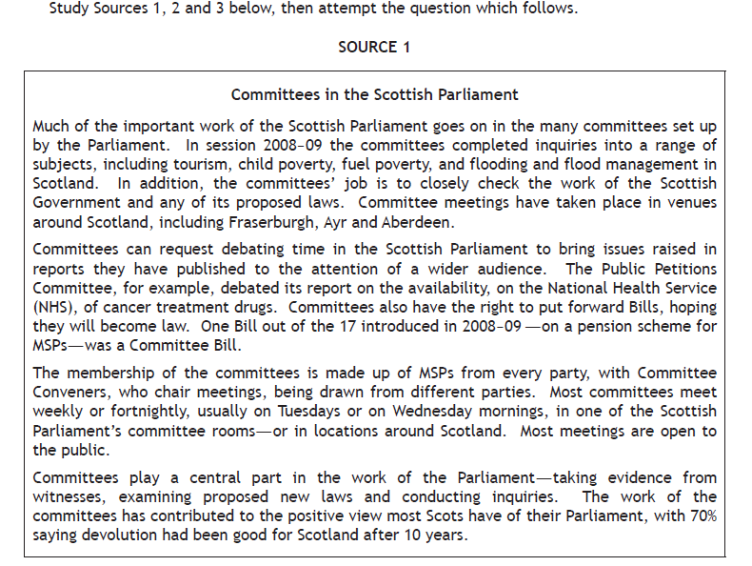

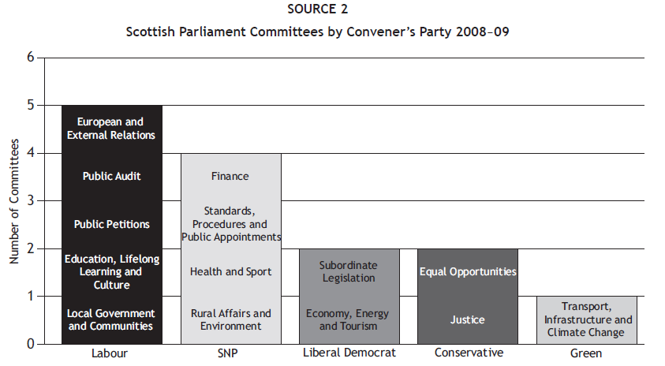

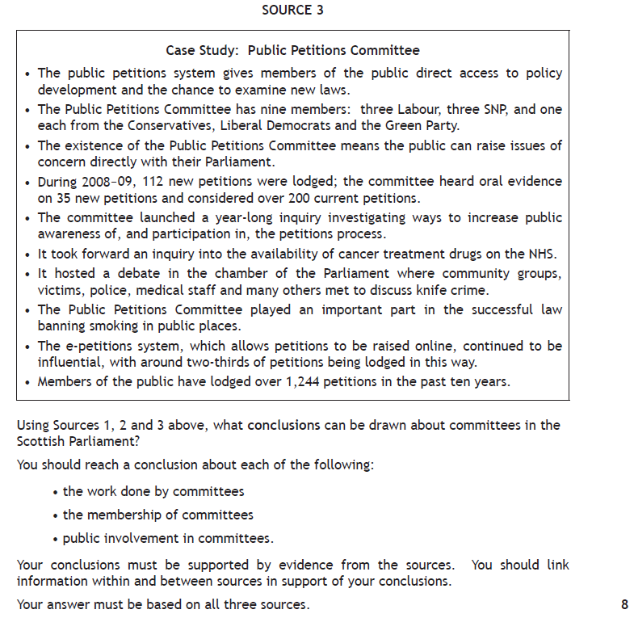

**CONCLUSIONS EXAMPLE 3**

Read Sources 1, 2 and 3, then answer the question which follows.



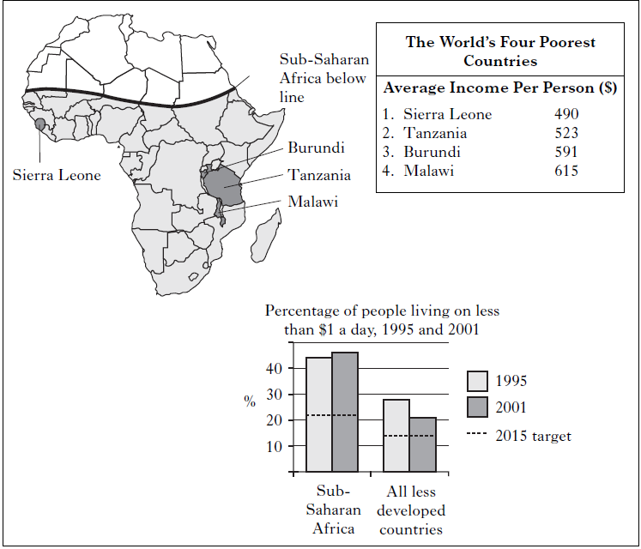

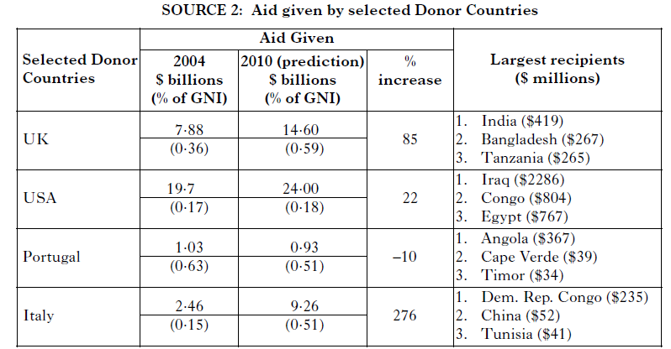

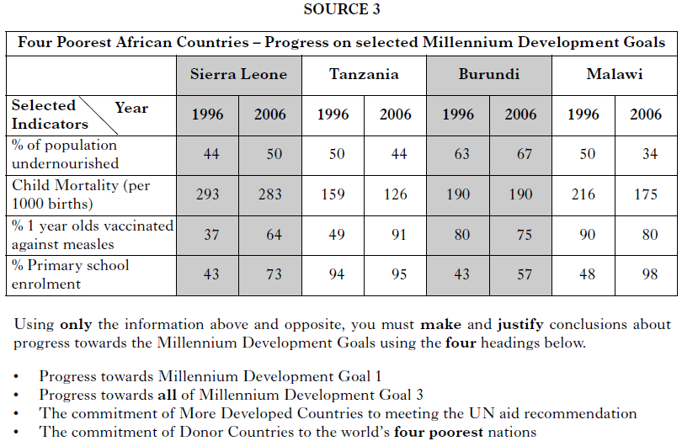

**CONCLUSIONS EXAMPLE 4**

(From 2013 Int 2)

Study Sources 1, 2 and 3 below and opposite, then answer the question which follows.

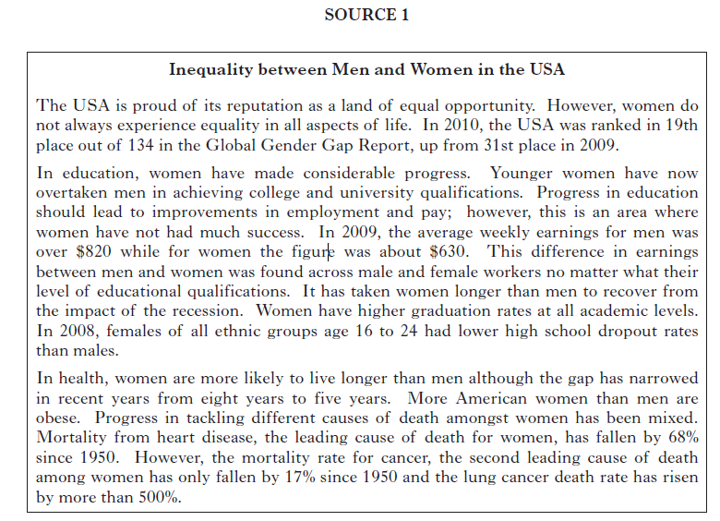

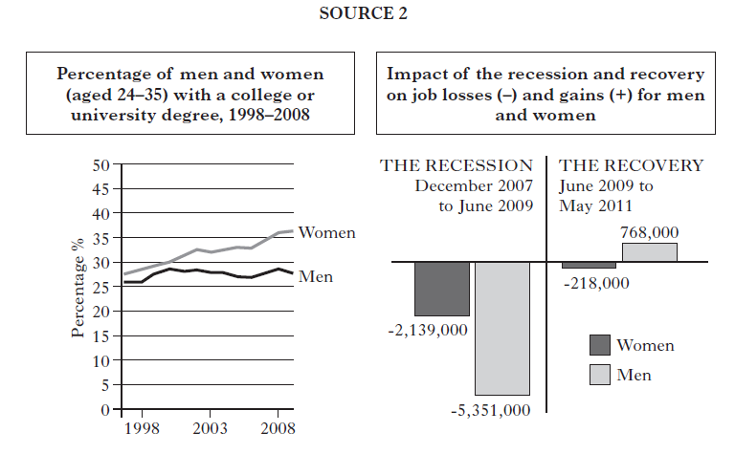

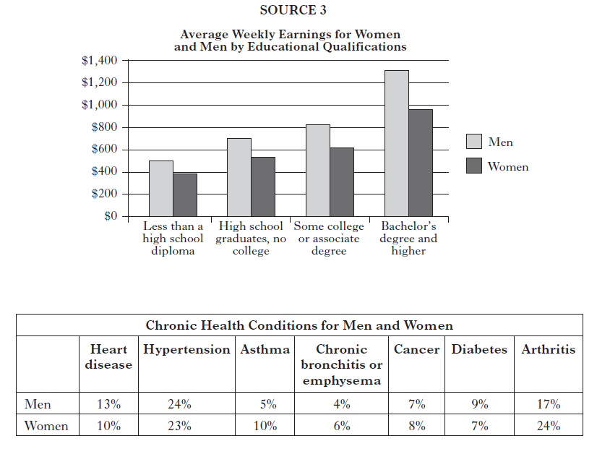

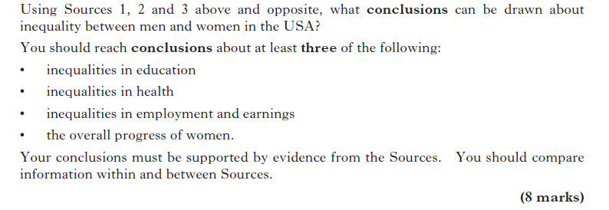

**CONCLUSIONS EXAMPLE 5**

(From 2012 Int 2)

Study Sources 1, 2 and 3 below and opposite, then answer the question which follows.

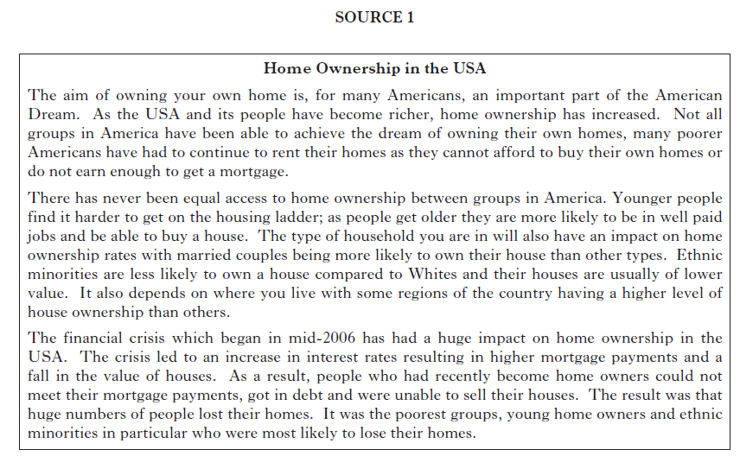

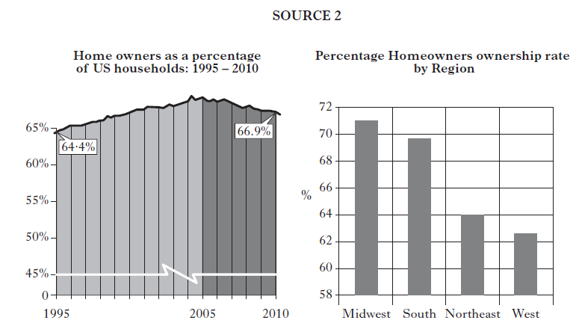

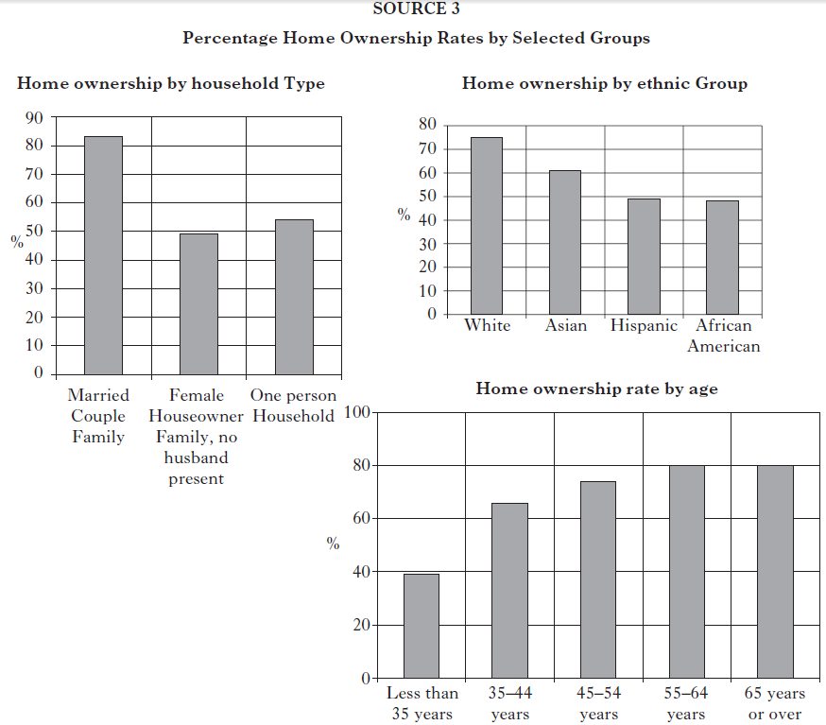

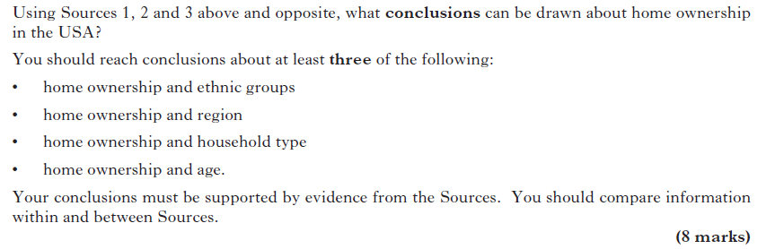

**CONCLUSIONS EXAMPLE 6**

(From 2011 SG C)

Study the information in the “**Spotlight on Trade Unions**” pamphlet below and

opposite, then answer the question which follows.

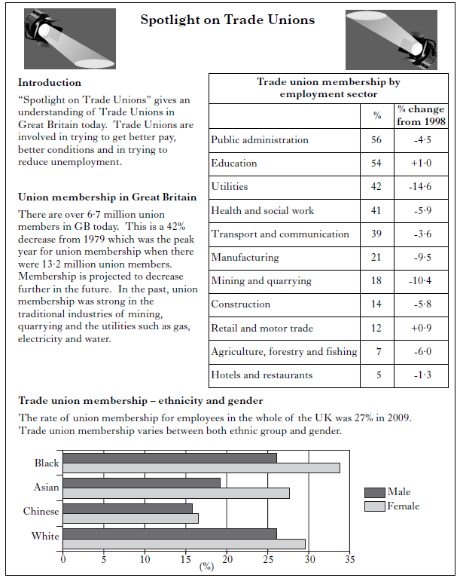

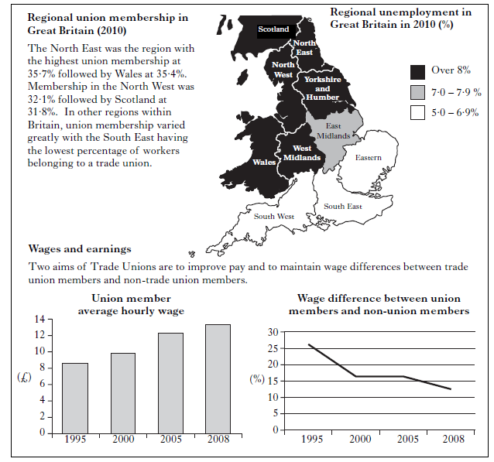

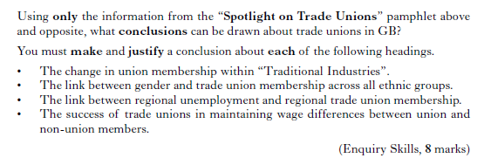

**CONCLUSIONS EXAMPLE 7**

(From 2009 SG C)

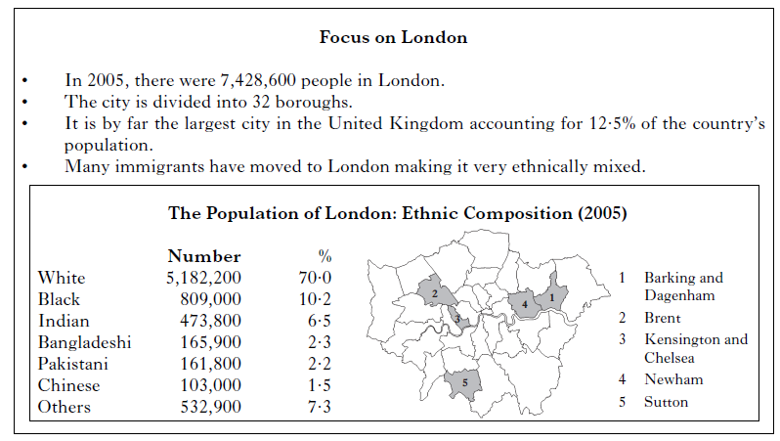

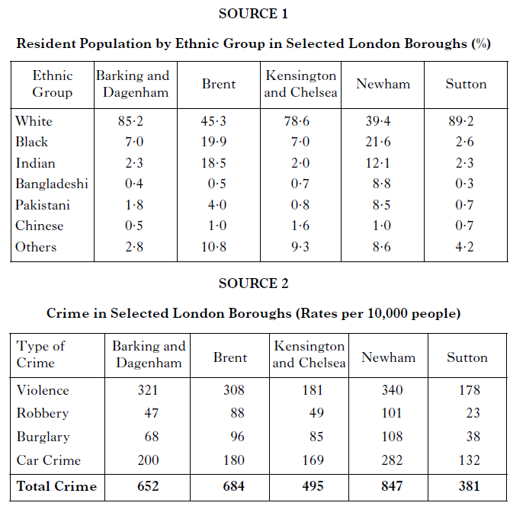

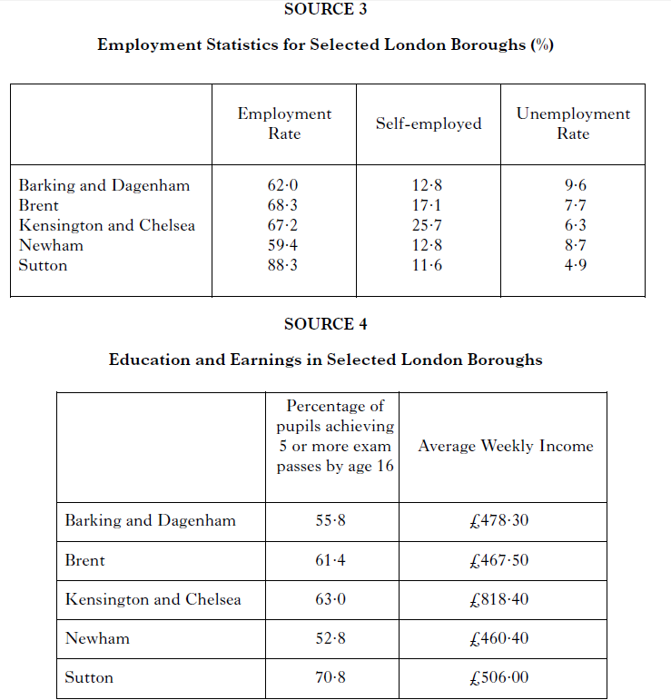

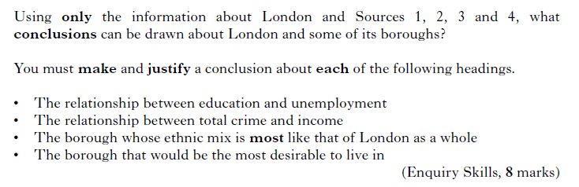

**END OF CONCLUSIONS EXAMPLES**