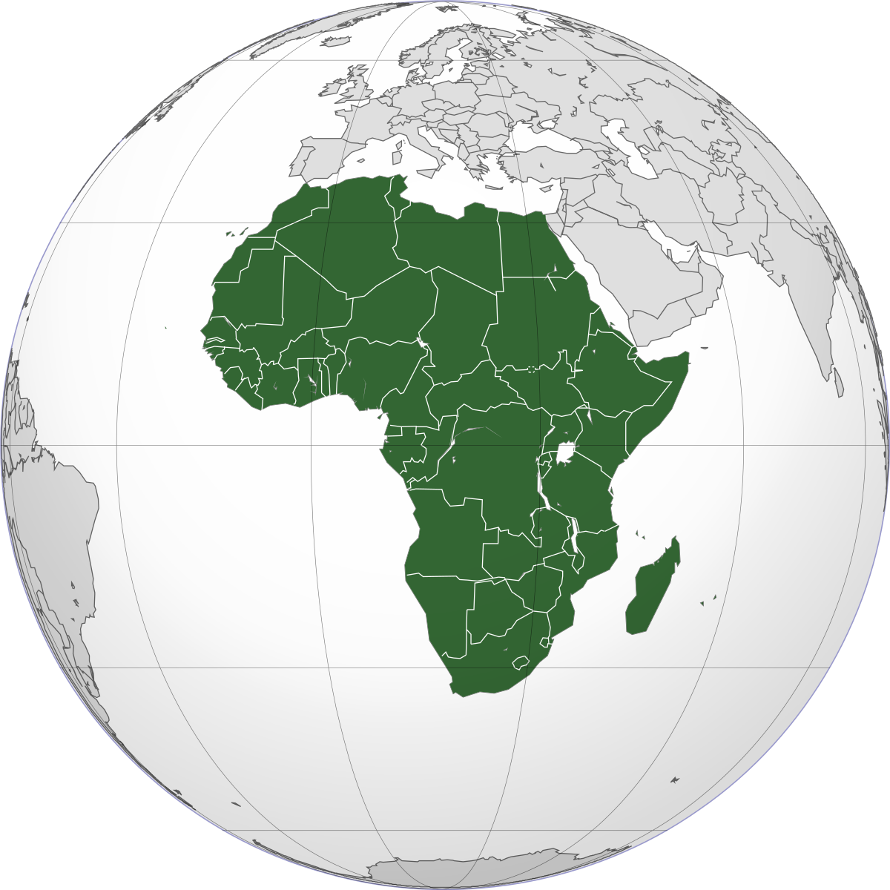
S2 Modern Studies

Welcome to S2 Modern Studies!

Our first topic is ‘The Developing World: Africa’ and throughout this we will look at many of the issues facing the continent of Africa, such as problems with healthcare, education and war.

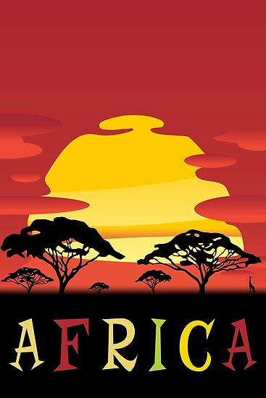
Your first task is to choose an African country (there are 54, so you have plenty of options) and create a poster about this country!

Your poster should include:

- The name of the country.
- A picture/drawing of their flag.
- At least 5 interesting facts about this country (you can use the internet to find info).

If possible, try to make your poster colourful and eye catching! We are aware that at home you may have limited access to materials, so don’t worry about making it perfect. Just be creative and do what you can.
Once you complete your poster, take a picture and tweet us at @SASB_SocSubject so we can see your work!

