New S2 Modern Studies lesson- Introduction to Africa

Hello New S2- we are continuing the Africa unit with an introduction to some key terms and a look at some differences between countries in Africa.
Please read the information below and complete the questions on page 3 on paper or a word document. This can be self-marked after Friday when the answers will be published on the school website under Social Subjects- Modern Studies- S1-2.

Africa is a diverse continent, made up of 54 different countries. It is the second largest continent in the world and has the second largest population (after Asia). It is made up of mountains and deserts, cities, tiny villages and everything in between. It has some of the richest people in the world and most of the poorest. Most people in Africa are either Christian or Muslim but there are also lots of other religions. In short, Africa is a fascinating and very different continent to Europe.
During our S2 course on Africa we will be considering how life differs between Britain and some African countries. We will also consider problems experienced within African countries and their causes and we will look at how organisations like the UN and charities help some African countries.

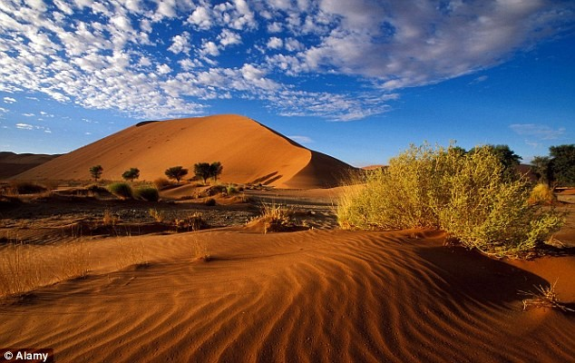 Desert, Namibia 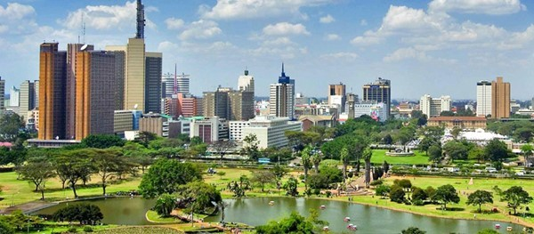
Nairobi, Kenya

Lesson 1 – Mapping Africa
Word bank:
Life Expectancy: The average age that people in a country live to
GDP per capita: The amount of money that a country produces per person in a year. This indicates how rich a country is compared to other countries
Population: The number of people living in a country
Sanitation: Access to toilets and wastewater facilities

Read the Fact file below and think about what the main differences are between Britain and the other countries.
 | Britain | Kenya | Nigeria | Malawi
Life Expectancy | 80.5 | 63.8 | 53.1 | 60.7
Number of children per woman | 1.89 | 3.31 | 5.19 | 5.6
Population | 64,088,222 | 45,925,301 | 181,562, 056 | 17,964,697
Access to clean water | 100% | 63.2% | 68.5% | 90.2%
Access to sanitation | 99% | 30.1% | 29% | 41%
Average school leaving age | 17 | 11 | 9 | 11
GDP per capita | $38,800 | $3,100 | $6,100 | $1,100

Activities – Please complete the questions below on paper or a word document and self-mark after Friday when the answers will be published on the school website under Social Subjects- Modern Studies- S1-2
- Read the Word bank carefully and write out the words and definitions that you are unfamiliar with. This will help you learn them.
- Which country has the longest life expectancy and which the shortest?
- In which country do women have the most children and in which country do they have the least?
- Which country has the largest population?
- Which country has the least access to clean water?
- Which country has the least access to sanitation?
- How many more years does the average child in the UK have at school in comparison to a) Malawi b) Nigeria?
- Which country is the poorest and how does its GDP compare to that of Britain?
Extension Activities
- What problems might lack of access to clean water and sanitation lead to?
- What problems might face children leaving school at the end of primary?
- Which country would you least like to live in? Explain your answer with reference to the table.

